Please leave comments about the design here

Main focuses:

-Good practice of wiring.

-Power connections correct?

-Operations of buzzer

Comments and Corrections:

There are 11 Resistors, 5 capacitors, 8 LEDs, 1 power switch, 1 transistor, 2 voltage regulators (5V, 3.3V), 1 buzzer, 1 MCU,and 2 battery mounts.

Personally I think this is a lot to throughhole solder. Possible solutions would be to take out functionalities ie too many LEDs, buzzer, etc. Or use some SMD components that are soldered and have the attendees solder rest throughhole components?

BOM: <https://docs.google.com/spreadsheets/d/1Oe2F8xR6RBt-0GckJ-ogD05bg7mY_HiMD3ofL3q5bEU/edit?usp=sharing>

**Overview of Design Graphic:** An IEEE keychain that can light up and play sound.

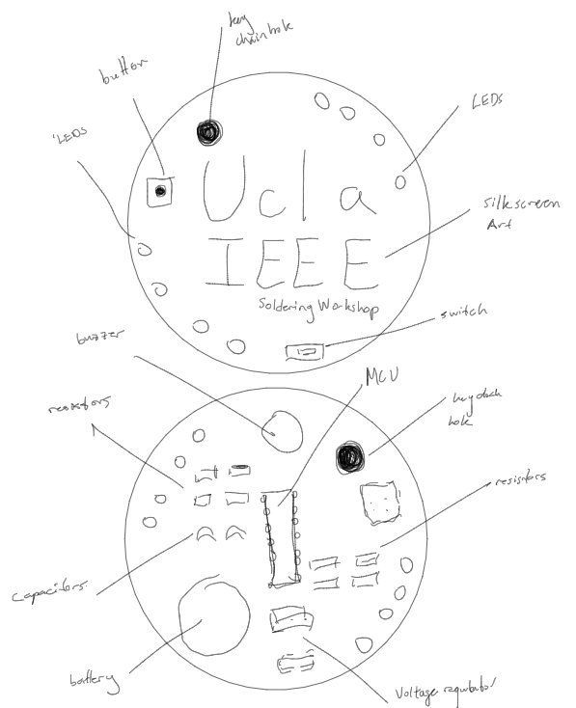

Front

Note: I’ve omitted the button.

Back

PM Notes:

LD1117V33 Regulator - Fine

LM7085 Regulator - Fine

MCU - ~~Leave Reset pin floating if you’re not planning to use it, it is internally pulled high~~

Henry: Reset is not necessary because there is a power-on-reset condition?  
 ~~Connect AREF to 5v~~

U~~se a different pin for Buzzer (pick a PWM one), that one is a mandatory oscillator pin~~

~~Connect LED 6 and LED 7 to different pins, those are used for serial communication~~

How are you going to program this thing?

Henry: Arduino uno

~~Buzzer - tbh if you want the buzzer to be louder you can use the 6v from the batteries to directly power it, that way you dont have to worry about the current limit from the 3.3v regulator and can remove the 3.3v regulator entirely (will need to find a different buzzer than can support a higher voltage and mean current)~~

~~Remove buzzer resistor and replace with a flyback diode~~

* ~~Not 100% sure, but PA3 may not support pwm/output a square wave of set frequency. The datasheet guarantees that PA5, PA6, and PA7 can do it. Not sure about PA3.~~
* Need to breakout some pins for programming
* ~~Consider adding decoupling caps next to the MCU~~

BOM - use parts from either digikey or mouser, try to avoid sparkfun, nvm sparkfun is approved

Some more comments on latest design 20190828

* ~~Decoupling caps should go right next to the things they decouple. Like the pins~~
* To make the lives of the solderers easier, make the silkscreen in large font and as clear as possible. Don’t put extraneous details on it, but do put pertinent ones. Namely, component designators (e.g. R2, C1, you don’t really need the value), battery polarity (maybe consider adding a schottky diode, something with low forward voltage, after the battery for reverse polarity protection) so people don’t fry the attiny
* You can try to organize things like resistors in a row to make the lives of the solderers easier. Not that important

Hardware version 1:

Needed Parts:

* Attiny and socket
* 1K resistors
* Coin cell battery mount
* 1uF cap

Comments:

* ~~Buzzer through-holes need to be narrower.~~
* ~~Keychain hole can be closer to edge~~
* ~~Shottky Diode can be a lot smaller~~
* ~~Mark the capacitors on silk~~
* ~~Switch is difficult to place. Make holes for Side handles~~
* ~~Linear voltage regulator sticks out a lot. Make so it can fold?~~
* ~~Create polarity for the MCU socket and MCU~~
* New coin cell mount
* ~~CHange switch on off polarity~~
* ~~Make sure the polarity of the buzzer is correct~~
* Easier way to take out the battery
* ~~Rename the silkscreen for LEDs~~
* ~~LED2 is currently set as the reset on attiny which is not end of the world. Changed to physical pin 5~~
* ~~The schottky diode can be replaced by a 1K resistor. So it is much louder.~~
* ~~Route the buzzer to the battery voltage.~~
* ~~Make silkscreen larger for LEDs~~
* New silkscreen design